|  |  |
| --- | --- |
| linear IPS | Year 12 Specialist  TEST 2  Monday 11 March 2019  TIME: 45 minutes working  Classpads allowed  One page of notes  45 marks 7 Questions |

Name:_______________________________

Teacher: ____________________________

**Note: All part questions worth more than 2 marks require working to obtain full marks.**

Q1 (2 & 3 = 5 marks)

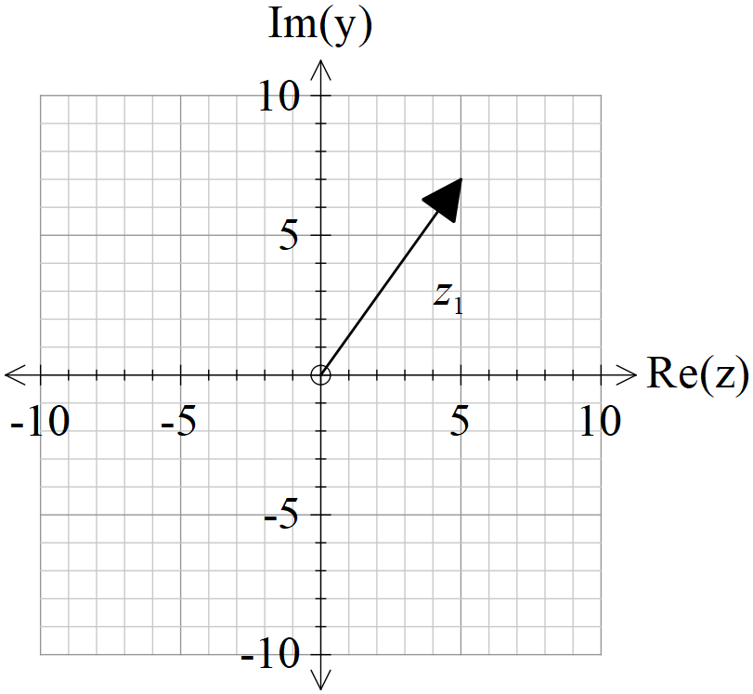

From the diagram,  is a solution to  for complex .

1. Determine .
2. Determine the other three roots and express in the form .

Q2 (2, 3 & 1 = 6 marks)

Let  and .

1. State the natural domain and range of .
2. Does  exist over the natural domain of ? If it does not, determine the largest possible domain for the composite to exist.
3. Determine 

Q3 (2, 3 & 2 = 7 marks)

Given that , , determine the following.

1.  and its domain.
2. Sketch on the axes below, 

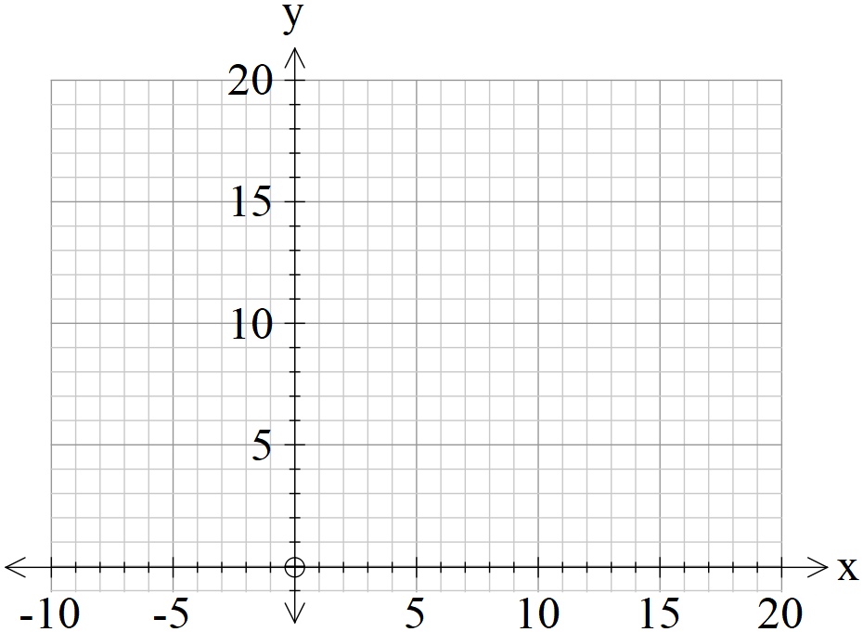

1. On the sketch above show the precise points where 

Q4 (2 & 3 = 5 marks)

Consider the function  for the questions below.

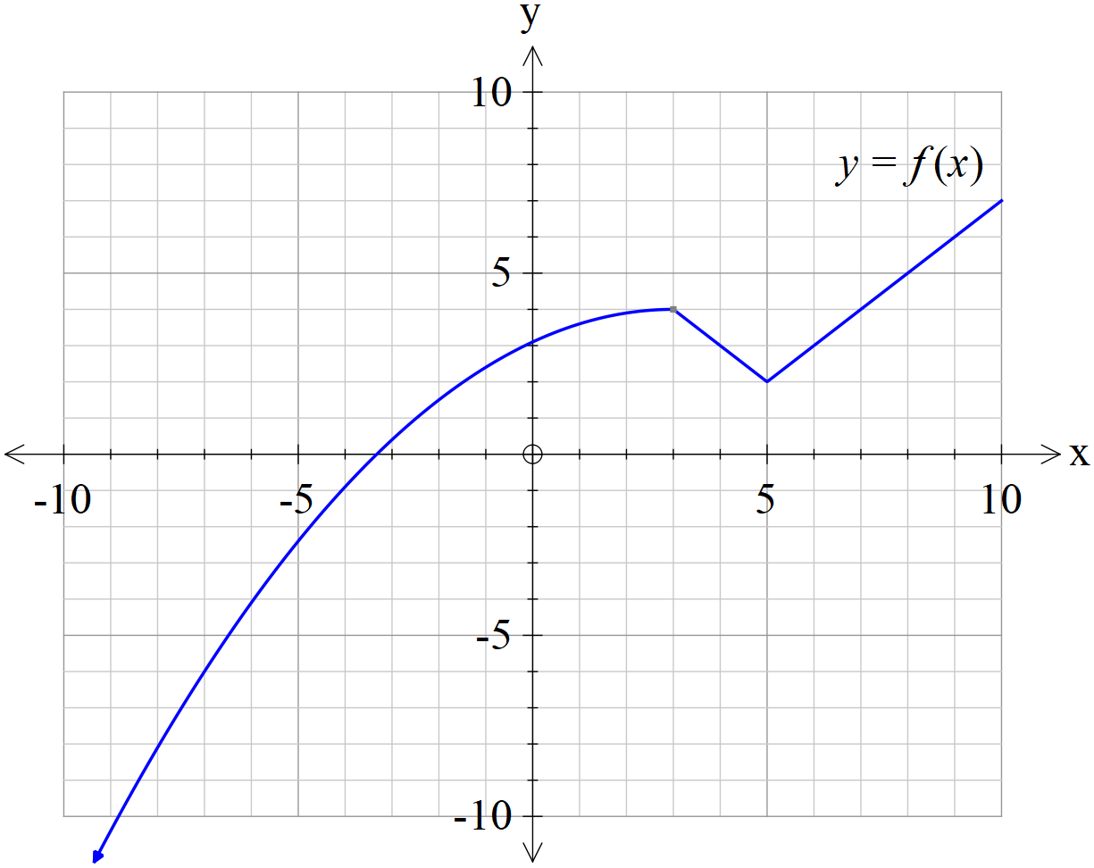

1. Sketch the function  on the axes below.

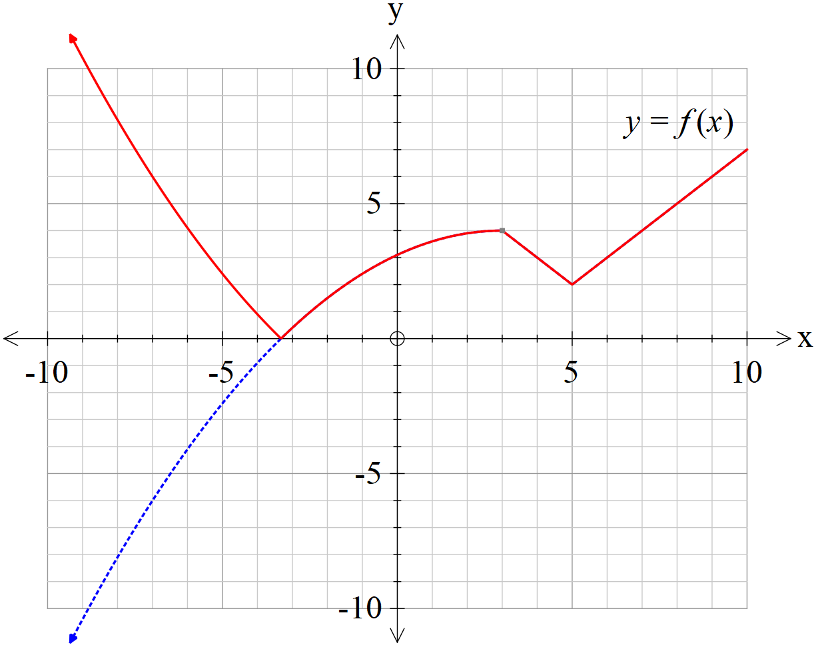

1. Sketch the function  on the axes below.

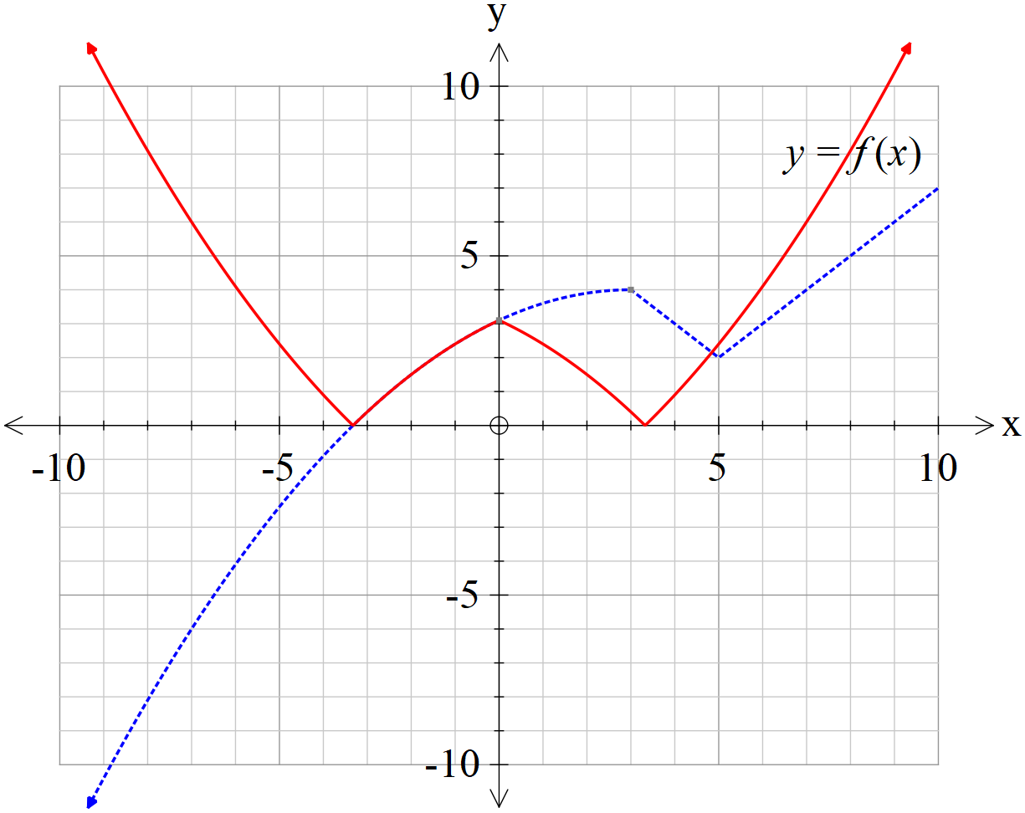

Q5 (3 & 4 = 7 marks)

Let  be the plane defined y .

1. Show that the cartesian equation of this plane is .
2. Let the sphere  have a centre , where  is a constant, and it is known that the plane is tangential to this sphere. Determine the value ofand the vector equation of the sphere .

Q6 (1, 1, 1, 3, 1 & 3 =10 marks)

The diagram below shows a triangle with vertices with . Let  be the origin, with vectors  and .

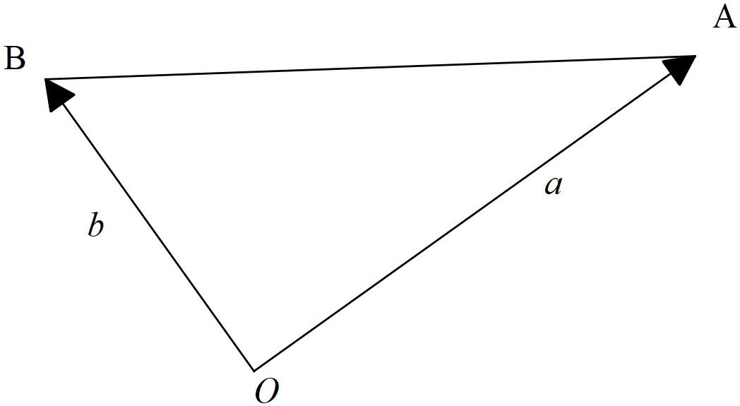

1. Determine the following vectors in terms of .
2. , where  is the midpoint of the line segment .

ii) 

1.  , where  is the midpoint of the line segment .

Let  be the midpoint of the line segment .

1. Use a vector method tom prove that the quadrilateral  is a parallelogram.

Q6 continued

Now consider the particular triangle  with  and  where  is a positive constant, chosen so that triangle  is isosceles, with .

1. Show that .
2. Use a vector method to show that  is perpendicular to .

Q7 (5 marks)

Let  where  is a real constant. Let , where  are real constants. If  for  and all roots of  satisfy , determine all possible values of .